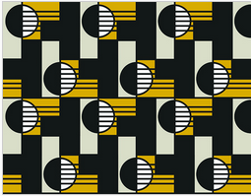
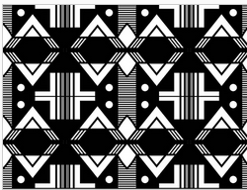
To match Before and After match colours
Heather to approve

Diverse Pattern by Bonolo Chepape Before and After by Bonolo Chepape

